

La Societe

des 40 Hommes et 8 Chevaux

Grande Voiture du Missouri



**2015 – 2016**

Directory

# **GRAND ROSTER**

**2015-2016**



#### “Our Greatest Fun is Service”

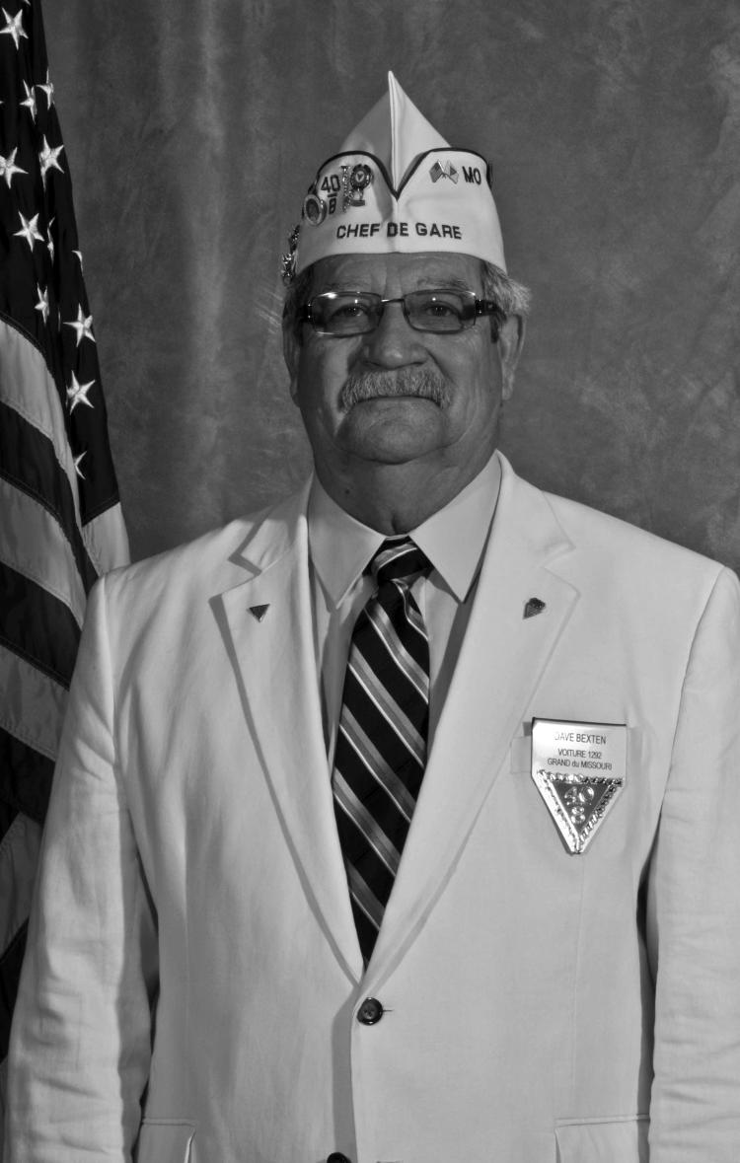

David Bexten

Grand Chef de Gare

2015 – 2016

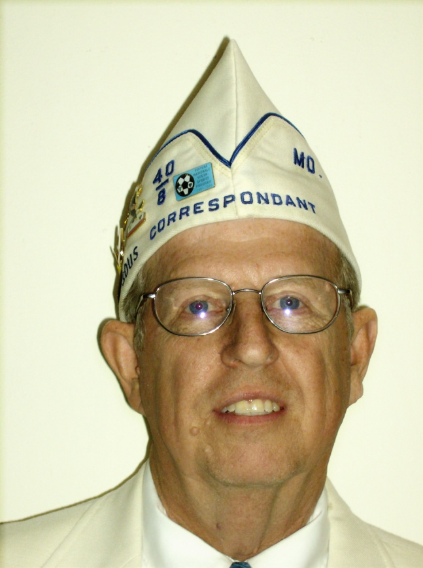

Terry L. Lanning

Grand Correspondant

2015 – 2016**Preamble**

For God and country we associate ourselves together for the following purposes: To create a charitable and non-profit veterans organization; to uphold and defend the Constitution of the United States of America; to assist and promote the welfare and well-being of those who served or are now serving in the Armed Forces of the United States and their widows, widowers and orphans; to participate in all memorial services for and to be present at the funerals of departed comrades; to take part in and to encourage others to participate in the proper observance of all days honoring veterans; to preserve the memories of our Services in the Armed Forces of our Country; to actively participate within our membership in projects relating to (a) the welfare of the children of America; (b) the health of our Nation by fostering a nurses training program; and (c) selected charitable endeavors.

### **Catechism of an Homme**

## “I faithfully promise to obey the rules and regulations of La Societe, to remember my obligations, and to carry out the legal orders of the Chef de Gare. I believe, for the good of my country, that I should and will always hold the organization of La Societe in highest esteem, and will conduct myself in such a manner as to reflect credit upon it. It is my sincere desire, that the United States of America, be one country, with one language, and one flag, and, if necessary, I will fight for that principle.”

**GRANDE VOITURE du MISSOURI**

**2015 - 2016 Directory**

GRAND CHEF de GARE (1292)

David Bexten Patty Res: 573-744-5366

1343 County Road 632 Cell: 573-690-4705

Freeburg, MO 65035 davidhbexten@gmail.com

GRAND CHEF de TRAIN (292) Lora

Thomas (Chip) Berkley Cell: 816-244-8411

2545 County Rd 269 Res: 573-424-8877

Columbia, MO 65202 tdberkley@msn.com

GRAND COMMISSAIRE INTENDANT (130)

David N. Voyles Ruth

PO Box 36 Res: 816-475-3151

Amazonia, MO 64421 voyles@centurytel.net

CHEMINOT NATIONALE (460)

Ralph Turner TinaPO Box 112 Res: 573-528-7424Richland, MO 65556 Ralph.N.Turner@hotmail.com

ALTERNATE CHEMINOT NATIONALE (1541)

Leon L. Hill Linda

1011 Pegasus Circle Res: 636-397-2850

St. Peters, MO 63376 lhill2@aol.com

GRAND CORRESPONDANT (448)

Terry L. Lanning Linda

2045 Granada Drive Res: 314-839-2032

Florissant, MO 63033 t_lanning@charter.net

SOUS GRAND CORRESPONDANT (448) Shirley

Leslie G. Willis, Jr. Res: 314-524-0034

#8 Shireford Lane Cell: 314-323-3903

Ferguson, MO 63135 willis.grant@sbcglobal.net

SOUS GRAND CHEF de TRAIN (Voitures-447-460-760-1395)

A J Noonan (460) Rose

20165 Highway 28 Res: 573-336-4516

Dixon, MO 65459 ajnoonan2004@yahoo.com

Advisor Kevin Johnson (460)

SOUS GRAND CHEF de TRAIN (Voitures-38-448-966-1321-1541)

Janice Hartley (1541) James 26 Jody Drive Res: 314-799-4568 St. Peters, MO 63376 jjhartley@charter.net

Advisor Robert Phillips (1541)

SOUS GRAND CHEF de TRAIN (Voitures-3-130-333-1379-1402)

Calvin Bumgarner (1379) Karen

5212 Cody Cell: 913-522-1103

Shawnee, KS 66203 cbumgar522@aol.com

Advisor Ed Jones (1379)

SOUS GRAND CHEF de TRAIN (Voitures-292-520-1292-1403)

Richard Pack (1292) Connie

4015 Cambridge Cr. Cell: 573-690-0308

Jefferson City, MO 65109 devildogpack@gmail.com

Advisor Larry Ebersold (1292)

GRAND AUMONIER (1379)

John Kopp Susan

5121 NE 47th Terr. Cell: 816-699-8719

Kansas City, MO 64117 jfkopp@att.net

GRAND AVOCAT (1321)

Richard A. Heigert Beverly

3202 Elm Grove Court Cell: 314-740-6685

Arnold, MO 63010 heigertr@aol.com

SOUS GRAND AVOCAT (448) Shirley

Leslie G. Willis, Jr. Res: 314-524-0034

#8 Shireford Lane Cell: 314-323-3903

Ferguson, MO 63135 willis.grant@sbcglobal.net

GRAND COMMIS VOYAGEUR (130)

Orval L. Jensen Zelma

P.O. Box 82

Gower, MO 64454-0082 Res: 816-424-3540

GRAND CONDUCTEUR (292)

Terry McDonald Barbara

405 S. Greenwood Ave. Res: 573-449-3790

Columbia, MO 65203 tbmcdonald@hotmail.com

SOUS GRAND CONDUCTEUR

Thomas Goodin (1292)

1829 A Cedar Ridge Res: 573-619-4400

Jefferson City, MO 65109 tkgoodin@centurylink.net

Ed Trube (1292) 1801 Shoshoni Drive Jefferson City, MO 65109 Res: 573-636-4621

Jerry Phelps (1379)

5020 N Topping Ave

Kansas City, MO 64119 Res: 816-645-6218

GRAND DRAPEAU EAST (38)

David S. Christian Jill

2082 State Road AA Res: 636-931-3568

Festus, MO 63028 DSChristian2082@aol.com

GRAND DRAPEAU WEST (3)

Kerry Boardman

1008 Shorthorn Dr. Res: 913-206-0466

Grain Valley, MO 64029 kerryboardman@yahoo.com

GRAND GARDE de LA PORTE (1379)

John Paul Kopp

5121 NE 47th Terr. Cell: 816-709-8340

Kansas City, MO 64117 jpkopp@att.net

GRAND HISTORIEN (1292)Richard Pack Connie

4015 Cambridge Cr. Cell: 573-690-0308

Jefferson City, MO 65109 devildogpack@gmail.com

GRAND LAMPISTE (1379)Vernon Hudspeth

PO BOX 7343 Res: 816-349-4499

Kansas City, MO 64116 v.hudspeth@hotmail.com

GRAND MEDICIN (760)

Errol N. Wilson Louella

3742 N. Delaware Res: 417-833-4530

Springfield, MO 65803 trkmn55@att.net

GRAND ORGANIZER (1541)

Robert W. Phillips Tina

314 Kent Drive Cell: 314-609-2492

Wentzville, MO 63385 tibo5635@charter.net

SOUS GRAND ORGANIZER

Clarence C. Buckley (760)

1325 N. Johnson Res: 417-866-8343

Springfield, MO 65802 chubb65@sbcglobal.net

Larry R. Ebersold (1292)

45 Denton Road

Eldon, MO 65026 Cell: 573-480-3652

GRAND PUBLICISTE (1379)

Robert C. Emery cell: 816-585-2809

16001 East 31st Street South Res: 816-313-5109

Independence, MO 64055 remery18@comcast.net

GRAND CHEMINOT-AT-LARGE

Robert G. Eisenbath (1541) Doris

26204 Bubbling Brook Drive

Foristell, MO 63348 Res: 636-673-0006

Kevin T. Johnson (460)

16810A Huntington Lane Res: 573-774-5825

St. Roberts, MO 65584 kthomasj01@yahoo.com

Arthur L. Wilson (448) Carol Res: 636-374-5354

3125 Country Bluff Dr. Cell: 314-680-8860

St. Charles, MO 63301 awilson725@att.net

Clarence C. Buckley (760)

1325 N. Johnson Res: 417-866-8343

Springfield, MO 65802 chubb65@sbcglobal.net

Robert W. Phillips (1541) Tina

314 Kent Drive Cell: 314-609-2492

Wentzville, MO 63385 tibo5635@charter.net

PROGRAM DIRECTEUR’S AND SOUS’S

GRAND DIRECTEUR AMERICANISM (1379)

Robert C. Emery cell: 816-585-2809

16001 East 31st Street South Res: 816-313-5109

Independence, MO 64055 remery18@comcast.net

SOUS GRAND DIRECTEUR AMERICANISM (1403)

Sam M. Guenther Jan

29247 Cardinal Lane

Gravois Mills, MO 65037 Res: 573-372-6562

GRAND DIRECTEUR BOX CAR (1379)

Edward P. Schmidt

PO Box 341 Res: 816-288-1612

Cameron, MO 64429 ed@maysvillemo.com

SOUS GRAND DIRECTEUR BOX CAR (448)

Hallie Williams (448) Yevette

6924 Willow Wood Drive Cell: 314-359-4748

Northwoods, MO 63121 Res: 314-381-7538

Shane Zimmer (1292)

PO BOX 74 Res: 573-259-1462

Freeburg, MO 65035 blame_me1223@yahoo.com

GRAND DIRECTEUR CARVILLE STAR

Mike Scruby (1379) Jill

7909 N. Little Lane Res: 816-781-9170

Pleasant Valley, MO 64155 mscruby@kc.rr.com

GRAND DIRECTEUR CHILD WELFARE (460)

Benjamin Sargent

25625 Swan Road Res: 573-765-3653

Richland, MO 65556 msgsgt2@yahoo.com

SOUS GRAND DIRECTEUR CHILD WELFARE (460) Marvin Tulla Diane

14175 Cairo Lane Cell: 573-337-8319

Dixon, MO 65459 malvin_651946@yahoo.com

GRAND DIRECTEUR NURSES TRAINING (1541) James Hartley Janice 26 Jody Drive Res: 314-607-1433 St. Peters, MO 63376 kc0wdb@yahoo.com

SOUS GRAND DIRECTEUR NURSES TRAINING (1541)

John “Jack” Spitler Cathy119 Satinwood Ct. Res: 636-922-3799 St. Charles, MO 63304 johnb22@sbcglobal.net

GRAND DIRECTEUR POW/MIA (460)

Frank Angelo Tina 132 Sawmill Rd. Res: 217-416-5695

St. Robert, MO 65584 fangelo618@aol.com

SOUS GRAND DIRECTEUR POW/MIA

Matt Ervin (460) Vicki

20882 Hogue Lane Res: 912-332-4550

St. Roberts, MO 65584 swervin3000@yahoo.com

Allen Schultz (1541)

1427 Summergate Pkwy Res: 636-447-7347

St. Charles, MO 63303 ajblues9243@sbcglobal.net

GRAND DIRECTEUR RITUAL (460)

Rose Noonan Arnold

20165 Highway 28 Res: 573-647-9162

Dixon, MO 65459 ajnoonan2004@yahoo.com

SOUS GRAND DIRECTEUR RITUAL (460)

Kevin T. Johnson

16810A Huntington Lane Cell: 573-586-8951

St. Roberts, MO 65584 kthomasj01@yahoo.com

GRAND DIRECTEUR SPECIAL AWARDS (292)

Robert E. Lee Judy

3201 A Mexico Gravel Road

Columbia, MO 65202 Res: 573-999-9056

SOUS GRAND DIRECTEUR SPECIAL AWARDS (HERO OF YEAR)

Michael Brueckmann (38) Diane

55 Oakwood Lane Res: 314-845-6858

St. Louis, MO 63129 brickman55@charter.net

SOUS GRAND DIRECTEUR SPECIAL AWARDS (LAW & ORDER)

Robert E. Lee (292) Judy

3201 A Mexico Gravel Road

Columbia, MO 65202 Res: 573-999-9056

GRAND VAVS CHAIRMAN (1292)

Thomas Goodin

1829 A Cedar Ridge Res: 573-619-4400

Jefferson City, MO 65109 tkgoodin@centurylink.net

SOUS GRAND VAVS CHAIRMAN

Billie Gammill (1379)

237 S. Huttig Ave. Res: 816-254-8645

Independence, MO 64053 billieg1953@yahoo.com

William H. Hoppe (1321)

125 Watts Street

Park Hills, MO 63601-1879 Res: 573-431-0329

GRAND DIRECTEUR VOITURE ACTIVITIES (448)

George W. Ridley Ninphia Res: 314-524-1942

#15 Shireford Lane Cell: 314-619-9395

Ferguson, MO 63135 geostuff@mail.com

SOUS GRAND DIRECTEUR VOITURE ACTIVITIES (460)

Chris Bryson Shaun24345 Trolley Lane Res: 573-855-8332 St. Robert, MO 65584 racefanman@gmail.com

GRAND DIRECTEUR YOUTH SPORTS (292)

Curtis Russell Pam

2580 W. Wilbert

Columbia, MO 65202 Res: 573-817-0330

SOUS GRAND DIRECTEUR YOUTH SPORTS (1379)

Ann Roberts

507 Park Street Cell: 660-744-3625

Tarkio, MO 64491 annroberts1@hotmail.comom

COMMITTEES

DISTINGUISHED GUEST COMMITTEE

Robert W. Phillips (1541) Tina

314 Kent Drive Cell: 314-609-2492

Wentzville, MO 63385 tibo5635@charter.net

Terry L. Lanning (448) Linda

2045 Granada Drive Res: 314-839-2032

Florissant, MO 63033 t_lanning@charter.net

Richard A. Heigert (1321) Beverly

3202 Elm Grove Court Cell: 314-740-6685

Arnold, MO 63010 heigertr@aol.com

DISTINGUISHED VOYAGEUR AWARD COMMITTEE Leslie G. Willis, Jr. (448) Shirley Res: 314-524-0034

#8 Shireford Lane (Chairman) Cell: 314-323-3903

Ferguson, MO 63135 willis.grant@sbcglobal.net

Terry L. Lanning (448) Linda2045 Granada Drive Res: 314 839-2032

Florissant, MO 63033 t_lanning@charter.net

Robert W. Phillips (1541) Tina

314 Kent Drive Cell: 314-609-2492

Wentzville, MO 63385 tibo5635@charter.net

Edward R. Jones (1379) Joyce

7104 East 132nd Street Res: 816-761-1120

Grandview, MO 64030 ed.jones13@yahoo.com

Ralph Turner (460) TinaPO Box 112 Res: 573-528-7424Richland, MO 65556 Ralph.N.Turner@hotmail.com

Leon L. Hill (1541) Linda

1011 Pegasus Circle Res: 636-397-2850

St. Peters, MO 63376 lhill2@aol.com

EXECUTIVE COMMITTEE ADVISORY & PROTOCOL

Richard A. Heigert (1321) Beverly

3202 Elm Grove Court Cell: 314-740-6685

Arnold, MO 63010 heigertr@aol.com

Leslie G. Willis, Jr. (448) Shirley Res: 314-524-0034

#8 Shireford Lane Cell: 314-323-3903

Ferguson, MO 63135 willis.grant@sbcglobal.net

TIME & PLACE COMMITTEE

Arthur L. Wilson (448) Carol Res: 636-724-0669

3125 Country Bluff Dr. (Chairman) Cell: 314-680-8860

St. Charles, MO 63301 awilson725@att.net

Kevin T. Johnson (460)

16810A Huntington Lane Res: 573-774-5825

St. Roberts, MO 65584 kthomasj01@yahoo.com

Larry R. Ebersold (1292)

45 Denton Road

Eldon, MO 65026 Cell: 573-480-3652

MAVO

LEGISLATIVE REPRESENTATIVE

Charles Goodin (1292) Claudia

2411 Yorktown Dr. Res: 573-636-4013

Jefferson City, MO 65109 charleysw3@embarqmail.com

DELEGATE at LARGE

Thomas Goodin (1292)

1829 A Cedar Ridge Res: 573-619-4400

Jefferson City, MO 65109 tkgoodin@centurylink.net

DELEGATES:

David Bexten (1292) Patty Res: 573-744-5366

1343 County Road 632 Cell: 573-690-4705

Freeburg, MO 65035 davidhbexten@gmail.com

Thomas (Chip) Berkley (292) Lora

2545 County Rd 269 Res: 573-424-8877

Columbia, MO 65202 tdberkley@msn.com

Terry L. Lanning (448) Linda

2045 Granada Drive Res: 314-839-2032

Florissant, MO 63033 t_lanning@charter.net

AIDE DE CAMP

Larry R. Ebersold (1292)

45 Denton Road

Eldon, MO 65026 Cell: 573-480-3652

GRAND CHEFS de GARE PASSE

1986 Edward "Al" Vidricksen (3)

2016 S.W. 4th Street

Lee's Summit, MO 64081-2225 Res: 816-524-6191

1997 Richard A. Heigert (1321) Beverly

3202 Elm Grove Court Cell: 314-740-6685

Arnold, MO 63010 heigertr@aol.com

1998 Ronald P. Doyon (3) Nancy

1313 N.E. Timbercreek Way Res: 816-246-8220

Lee's Summit, MO 64086 ronalddoyon@att.net

2000 Terry L. Lanning (448) Linda

2045 Granada Drive Res: 314-839-2032

Florissant, MO 63033 t_lanning@charter.net

2002 Robert G. Eisenbath (1541) Doris

26204 Bubbling Brook Drive Res: 636-673-0006

Foristell, MO 63348 robo68@centurylink.net

2004 Arthur L. Wilson (448) Carol Res: 636-724-0669

3125 Country Bluff Dr. Cell: 314-680-8860

St. Charles, MO 63301 awilson725@att.net

2005 Kevin T. Johnson (460)

605 Wildwood Lane Cell: 573-586-8951

Waynesville, MO 65583 kthomasj01@yahoo.com

2006 Clarence C. Buckley (760)

1325 N. Johnson Res: 417-866-8343

Springfield, MO 65802 chubb65@sbcglobal.net

2007 Donald W. Fligge (3) Yvonne

P.O. Box 3321

Independence, MO 64055-8321 Res: 816-478-1901

GRAND CHEFS de GARE PASSE (continued)

2008 Leslie G. Willis, Jr. (448) Shirley Res: 314-524-0034

#8 Shireford Lane Cell: 314-323-3903

Ferguson, MO 63135 willis.grant@sbcglobal.net

2009 Robert W. Phillips (1541) Tina

314 Kent Drive Cell: 314-609-2492

Wentzville, MO 63385 tibo5635@charter.net

2010 Gary L. Reno (1379) Anne Res: 816-628-5773

1301 Robin Circle Cell: 816-718-1820

Kearney, MO 64060 greno001@kc.rr.com

2011 Larry R. Ebersold (1292)

45 Denton Road

Eldon, MO 65026 Cell: 573-480-3652

2012 David S. Christian (38) Jill

2082 State Road AA Res: 636-931-3568

Festus, MO 63028 DSChristian2082@aol.com

2013 Edward R. Jones (1379) Joyce

7104 East 132nd Street Res: 816-761-1120

Grandview, MO 64030 ed.jones13@yahoo.com

2013 Honorary

William A. Russell (130)

8371 NW Grimes Road

Stewartsville, MO 64490 Res: 816-424-3222

2014 Ralph Turner (460) TinaPO Box 112 Res: 573-528-7424Richland, MO 65556 Ralph.N.Turner@hotmail.com

2015 Leon L. Hill (1541) Linda

1011 Pegasus Circle Res: 636-397-2850

St. Peters, MO 63376 lhill2@aol.com

VOITURE LOCALE OFFICERS

VOITURE # 3

Meets on the last Thursday of month at 6:00pm

at Post 189, 820 Vista Dr., Lee’s Summit.

CHEF de GARE

Mark Suthers Lorena

508 NE Auburn

Lees’s Summit, MO 64086 Res:816-272-5323

CORRESPONDANT

John R. Neger Peggy

12113 E. 54th Terrace Res: 816-358-0508

Kansas City, MO 64133-3072 jneger@kc.rr.com

GRAND CHEMINOTKerry Boardman

1008 Shorthorn Dr. Res: 913-206-0466

Grain Valley, MO 64029 kerrylb59@yahoo.com

VOITURE # 38

Meets the 3rd Monday at 7:00pm,Voiture 38's Chateau, 4656 Minnesota

CHEF de GARE

Terry L. Davis

2017 Menard Street

St. Louis, MO 63104 Res: 314-723-2125

CORRESPONDANT

Gerald J. Fitzgerald Julie Res: 314-843-7312

#7 Zinzer Court Bus: 314-544-7100

St. Louis, MO 63123 gfitz05@att.net

GRAND CHEMINOT

VOITURE LOCALE OFFICERS

VOITURE # 130

Meets on the 3rd Thursday at Denny’s, 4015 Frederick Ave.,

St. Joseph, MO 64506 at 12:00pm

CHEF de GARE

John B. Miller

5510 S. 39th Terrance. Res: 816-390-1020

St. Joseph, MO 64503 jbmiller56@yahoo.com

CORRESPONDANT

James C. Jones Judy

407 N. 5th Street. Res: 816-324-4552

St. Savannah, MO 64485 jonesj51@hotmail.com

GRAND CHEMINOT

Orval L. Jensen Zelma

P.O. Box 82

Gower, MO 64454-0082 Res: 816-424-3540

VOITURE # 292

Meets on the 1st Wednesday at various towns & Posts.

CHEF de GARE

Danny Farris Renee

294 Old County Rd 398

New Bloomfield, MO 65063 Res: 573-469-5044

CORRESPONDANT Leslie E. Davis Marie

610 Meadowbrook Circle Res: 660-263-5612

Moberly, MO 65270 davisdemi@scglobal.net

GRAND CHEMINOT

Robert Lee Judy

3201 A Mexico Gravel Road

Columbia, MO 65202 Res: 573-999-9056

VOITURE LOCALE OFFICERS

VOITURE # 333

Meets on the 3rd Thursday, 7:45 AM. Sedalia Knights of Columbus

CHEF de GARE

Don Barbour

1611 S. Carr Res: 660-826-2102

Sedalia, MO 65301 dbarbour5@charter.net

CORRESPONDANT

Ernie Parker Susan

27659 Schenk Road Res: 660-619-3557

Green Ridge, MO 65332 susnerne@hughes.net

GRAND CHEMINOT

Tony J. Gallagher Jean

2705 S. Ohio Res: 660-287-4016

Sedalia, MO 65301 irishsgt7@gmail.comt

VOITURE # 447

Meets at various times.

CHEF de GARE

Orville Rebel

81 Coachlight Lane

Kimberling City, MO 65686

CORRESPONDANT

Orville Rebel

81 Coachlight Lane

Kimberling City, MO 65686

GRAND CHEMINOT

Orville Rebel

81 Coachlight Lane

Kimberling City, MO 65686

VOITURE LOCALE OFFICERS

VOITURE # 448

Meets on the 4th Tuesday 7:30 PM at Elks Club 2242 Mason Lane,

Manchester, MO 63021

CHEF de GARE

Michael A. Moore Sandy

712 Lynn Haven Lane Res: 314-895-3274

Florissant, MO 63043 icvmc.mustang@gmail.com

CORREPONDANT Shirley

Leslie G. Willis, Jr. Res: 314-524-0034

#8 Shireford Lane Cell: 314-323-3903

Ferguson, MO 63135 willis.grant@sbcglobal.net

GRAND CHEMINOT Yevette

Lindell O. Bast Barbara

2579 Lindsay Lane Res: 314-838-4284

Florissant, MO 63034 drwho650@yahoo.com

VOITURE # 460

Meets 3rd Tuesday 6:00PM at Post 331, 484 North Outer Road, St. Robert

CHEF de GARE

Vicki Ervin Matt 16855 Lemming Lane Res: 573-337-5211

St. Robert, MO 65584 blondpeach52000@yahoo.com

CORRESPONDANT Matt Ervin Vicki 16855 Lemming Lane Res: 573-337-5211

St. Robert, MO 65584 swervin3000@yahoo.com

GRAND CHEMINOT

Frank Angelo Tina 132 Sawmill Rd. Res: 217-416-5695

St. Robert, MO 65584 fangelo618@aol.com

VOITURE LOCALE OFFICERS

VOITURE # 520

Meets at various times.

CHEF de GARE

Dennis Van Bibber Mary34615 State Hwy W Res: 636-456-4544

Warrenton, MO 63383 dennisvanbibber47@yahoo.com

CORRESPONDANT

Sean Burrows 21389 Lake View Estates Dr. Res: 636-484-2912

Warrenton, MO 63383 puffy.needcomb@yahoo.com

GRAND CHEMINOT

Dennis Van Bibber Mary34615 State Hwy W Res: 636-359-6130

Warrenton, MO 63383 dennisvanbibber47@yahoo.com

VOITURE # 760

Meets on the 4th Tuesday, at Post 676, 69, or 639.

CHEF de GARE

Bob Cole Kathy

2623 N National

Springfield, MO 65803 Res: 417-838-2338

CORRESPONDANT

Errol N. Wilson Louella

3742 N. Delaware Res: 417-833-4530

Springfield, MO 65803 trkmn55@att.net

GRAND CHEMINOT

Roger Wallenburg Julie

1361 E. Woodgate Res: 417-425-5546

Springfield, MO 65804 rwallenburg@yahoo.com

VOITURE LOCALE OFFICERS

VOITURE # 966

Meets at various times.

CHEF de GARE

Robert W. Fohey Marcia

818 Spur Drive

Palmyra, MO 63461 Res: 573-769-2062

CORRESPONDANT

Larry R. Pickett Cathy

4317 West Ely Road Res: 573-221-4870

Hannibal, MO 63401 larrypickett1950@gmail.com

GRAND CHEMINOT

Larry R. Pickett Cathy

4317 West Ely Road Res: 573-221-4870

Hannibal, MO 63401 larrypickett1950@gmail.com

VOITURE # 1292

Meets on the 2nd Thursday 7:00PM usually at Post 5, 1423 Tanner Bridge Road, Jefferson City, MO 65101

CHEF de GARE

Ted Sigite

833 S. Summit Drive

Holts Summit, MO 65043 Res: 573-896-0198

CORRESPONDANT

Vincent Rost

2514 Scenic Drive Res: 757-754-1112

Jefferson City, MO 65101 vince.rost@yahoo.com

GRAND CHEMINOT

Richard Pack (1292) Connie

4015 Cambridge Cr. Cell: 573-690-0308

Jefferson City, MO 65109 devildogpack@gmail.com

VOITURE LOCALE OFFICERS

VOITURE # 1321

Meets on Sunday each month at various Posts at 1:00 PM.

CHEF de GARE

George Pottgen

4433 US Hwy 61 Res: 314-724-3807

Bloomsdale, MO 63637 tropperg101@yahoo.com

CORRESPONDANT Beverly

Richard A. Heigert

3202 Elm Grove Court Cell: 314-740-6685

Arnold, MO 63010 heigertr@aol.com

GRAND CHEMINOT

William Hoppe

125 Watts Street

Park Hills, MO 63601 Res: 573-431-0329

VOITURE # 1379

Meets on the 4th Wednesday at 7:00 PM at various places. Web site http://www.voiture1379.com

CHEF de GARE

Calvin Bumgarner Karen

5212 Cody Res: 816-734-5579

Shawnee, KS 66203 cbumgar522@aol.com

CORRESPONDANT

Robert C. Emery cell: 816-585-2809

16001 East 31st Street South Res: 816-313-5109

Independence, MO 64055 remery18@comcast.net

GRAND CHEMINOT

Calvin Bumgarner Karen

5212 Cody Res: 816-734-5579

Shawnee, KS 66203 cbumgar522@aol.com

VOITURE LOCALE OFFICERS

VOITURE # 1395

Meets at various times.

CHEF de GARE

LaVern P. Gisselbeck

19234 Highway “W”

Phillipsburg, MO 65722 Res: 417-532-9664

CORRESPONDANT Carolyn

John B. Doane Res: 417-924-8186

1717E. Republic Road FAX: 417-924-8596

Springfield, MO 65804-9513 skysoldier2@juno.com

GRAND CHEMINOT Carolyn

John B. Doane Res: 417-924-8186

1717E. Republic Road FAX: 417-924-8596

Springfield, MO 65804-9513 skysoldier2@juno.com

VOITURE # 1402

Meets at various times.

CHEF de GARE

Marvin E. Harper Mary

RR 2 Box 127 Res: 660-652-3291

Barnard, MO 64423 marehar@grm.net

CORRESPONDANT

Steven H. Hoffrogge

409 Broad Street Res: 660-736-5674

Tarkio, MO 64491-1517 sirgolferfrog@embarqmail.com

GRAND CHEMINOT

Marlin F. Slagle Sharon

1260 W. Crestview Drive

Maryville, MO 64468 Res: 660-582-2914

VOITURE LOCALE OFFICERS

VOITURE # 1403

Meets on the 3rd Tuesday at Post 624, 852 American Legion Rd, Sunrise Beach, MO 65079.

CHEF de GARE Jim Yahnke Mary

28595 Horseshoe Lane

Gravois Mills, MO 65037 Res: 573-372-6765

CORRESPONDANT Cindy

Robert B. "Barry" Campbell, Jr. Cell: 573-216-3605

115 Dunwunken Road Res: 573-374-9114

Gravois Mills, MO 65037 campjr48@yahoo.com

GRAND CHEMINOT Cindy

Robert B. "Barry" Campbell, Jr. Cell: 573-216-3605

115 Dunwunken Road Res: 573-374-9114

Gravois Mills, MO 65037 campjr48@yahoo.com

VOITURE # 1541

Meets on the 4th Wednesday at 7:30 PM at various Posts.

CHEF de GARE

John “Jack” Spitler Cathy 119 Satinwood Ct. Res: 636-922-3799 St. Charles, MO 63304 johnb22@sbcglobal.net

CORRESPONDANT

James Hartley Janice 26 Jody Drive Res: 314-607-1433 St. Peters, MO 63376 kc0wdb@yahoo.com

GRAND CHEMINOT

James Hartley Janice 26 Jody Drive Res: 314-607-1433 St. Peters, MO 63376 kc0wdb@yahoo.com

CHEFS de CHEMIN de FER PASSE

1953 * John O. Newberry 1292

1965 * O. J. Laubenthal 38

GRAND CHEFS de GARE PASSE

1921 * John H. Parker 38

1922 * Harry D. McBride 38

1923 * Dr. Paul V. Wooley 3

1924 * Francis M. Curlee 38

1925 * Clark R. Mandigo 3

1926 * Robert D. Turner 38

1927 * Hugh D. Mason 293

1928 * W. Vincent Brennan 448

1929 * Clem M. White 130

1930 * Charles L. Brown 760

1931 * Tom A. J. Anseim 448

1932 * James R. Anserson 3

1933 * Joseph F. Healy 130

1934 * Jake H. Karchmer 760

1935 * Arthur A. Jordan 38

1936 * George Fiske 3

1937 * Curt E. Kuehn 130

1938 * Dr. H. Chris Oltman 293

1939 * A. B. Weyer 3

1940 * Percy M. Gash 38

1941 * Clyde H. Ormsbee 760

1942 * Charles E. Teel 3

1943 * John J. Barada 38

1944 * Bartlett Boder 130

1945 * Fred A. Carlton 637

1946 * John O. Newberry 292

1947 * Vaughan T. Williams 3

1948 * John Bell 4481949 * F. Lee Price 38

1950 * Frank P. Reynolds 333

1951 * E. Farmer Oakes . 848

GRAND CHEFS de GARE PASSE (cont.)

1952 * J. Ralph Hutchison 156

1953 * C. Ray Drummond 448

1954 * Lester B. Miller 130

1955 * Mel Whiteside 1292

1956 * Neil F. Cline 3 1957 * W. Lee Morgan 38

1958 * P. A. Fredericksen 1379

1959 * Dr. H. V. Herider 333

1960 * O. E. Blankenbaker 448

1961 * Ralph S. Holland 3

1962 * O. J. Laubenthal 38

1963 * Cecil Montgomery 293

1964 * Robert E. Natsch, Jr 1292

1965 * Raymond O. Money 3 1966 * Charles E. Peebles 1379

1967 * Russell H. Miller 333

1968 * Clarence W. Bowers 38

1969 * John J. Peacock 3

1970 * Harold T. Most 38

1971 * Roy L. Carver 292

1972 * Robert W. Turina 448

1973 * Arthur G. Yoder 3

1974 * William P. Osthoff 130

1975 * Paul D. Hamilton 38

1976 * C. L. Stadtler 760

1977 * W. D. Jones 301

1978 * W. H. (Harold) Evans 3

1979 * Henry J. Renz, Jr. 38

1980 * Roger L. Goray, Sr. 448

1981 * Ira A. Hassenpflug 130

1982 * Charles W. Mickey 1292

1983 * George W. Powell 292

1984 * Raymond J. Brodzinski 38

1985 * Merton I. Adreon 448

1986 Al Vidricksen 3

1987 * Wayne S. Gregory 760

GRAND CHEFS de GARE PASSE (cont.)

1988 * Joe P. Yeargain 1321 1989 * James C. Henson 1379

1990 * George G. Gilmour 38

1991 * Robert T. Wilde 448

1992 * Donald E. Adams 1402

1993 * Paul M. Beck 1292

1994 * Richard A. Swope 1379

1995 * Jack M. Smith 38

1996 * Jerry J. Castulik 448

1997 Richard A. Heigert 1321

1998 * Jerry D. Key 1541

1998 Ronald P. Doyon 3

1999 * William H. Moore 38

2000 Terry L. Lanning 448

2001 * Virgil C. Morice 1321

2002 Robert G. Eisenbath 1541

2003 * Norman I. Reichel 1403

2004 Arthur L. Wilson 448

2005 Kevin T. Johnson 460

2006 Clarence C. Buckley 760

2007 Donald W. Fligge 3

2008 Leslie G. Willis, Jr. 448

2009 Robert W. Phillips 1541

2010 Gary L. Reno 1379

2011 Larry R. Ebersold 1292

2012 David S. Christian 38

2013 Edward R. Jones 130

2014 Ralph Turner 460

2015 Leon Hill 1541

HONORARY GRAND CHEFS de GARE PASSE

1983 * Dr. Benjamin S. Jolly 292

1984 * Elmer E. Kuhs 38

1992 * William L. Weiss 38 2013 William A. Russell ……………………………130

* DECEASEDGRANDE du MISSOURI VOITURES' HISTORY

VOITURE - 3 - Charter date of November 4, 1920 for Jackson County. HEART OF AMERICA VOITURE TROIS.

VOITURE - 38 - Charter date of January 31, 1921 for St. Louis City. SPIRIT OF ST. LOUIS VOITURE 38.

VOITURE - 130 - Charter date of September 21, 1921 for Buchanan County. JESSE JAMES VOITURE 130.

VOITURE - 292 - Charter date of June 23, 1922 for Boone County. HEART OF MISSOURI VOITURE 292.

VOITURE - 333 - Charter date of March 12, 1944 for the 7th District in Saline, Howard, Lafayette, Pettis, Benton & Hickory Counties. RUSSELL H. MILLER VOITURE 333.

VOITURE - 447 - Charter date of July 2, 1992 for Stone & Taney Counties. TABLE ROCK LAKE VOITURE 447.

VOITURE - 448 - Charter Date of November 6, 1922 for St. Louis County. GATEWAY VOITURE 448.

VOITURE - 460 - Charter date of April 22, 1985 for Pulaski County. CENTRAL OZARK VOITURE 460.

VOITURE - 520 - Charter date of March 22, 1923 for Audrain, Calloway, Monroe, & Montgomery Counties. COON COOKERS VOITURE 520.

VOITURE - 760 - Charter date of October 24, 1924 for Greene County. KICKAPOO VOITURE 760.

VOITURE - 966 - Charter date of December 1, 1947 for Marion County. MARK TWAIN VOITURE 966.

GRANDE du MISSOURI VOITURES' HISTORY (cont.)

VOITURE - 1292 - Charter date of June 23, 1947 for Cole County. CAPITOL VOITURE 1292.

VOITURE - 1321 - Charter date of March 18, 1948 for St. Francois County. MINERAL AREA VOITURE 1321.

VOITURE - 1379 - Charter date of October 18, 1949 for Caldwell County. NEUF COMPT VOITURE 1379.

VOITURE - 1395 - Charter date of April 30, 1950 for Webster, Laclede, Pulaski, and Phelps Counties. HEART OF THE OZARKS VOITURE 1395.

VOITURE - 1402 - Charter date of August 3, 1950 for Atchison, Nodaway, & Holt Counties. ATCHISON, NODAWAY, HOLT COUNTIES VOITURE 1402.

VOITURE - 1403 - Charter date of January 11, 1990 for Camden County. LAKE OF THE OZARK VOITURE 1403.

VOITURE - 1541 - Charter date of March 20, 1974 for St. Charles County. TWO RIVERS VOITURE 1541.

CHARTERS TURNED INTO THE GRANDE VOITURE

VOITURE 156 - Chartered December 14, 1987, Semo County.

VOITURE 293 - Chartered June 23, 1922, for Jasper County.

VOITURE 301 - Chartered June 30, 1922, Missouri Valley.

VOITURE 637 - Chartered October 15, 1923, Grundy County.

VOITURE 848 - Chartered June 8, 1938, 6th District.

VOITURE 1577 - Chartered June 22, 2003 for Benton, Hickory, Henry, &

St. Clair Counties.

GRAND CHEF de GARE PASSE WIDOWS

Janett Adams

711 Broad Street

Tarkio, MO 64491 Res: 660-736-4565

Juanita "Neet" Key

2701 Westminster

St. Charles, MO 63301 Res: 636-946-2782

Joanne Moore

1078 Bluebonnet Dr.

Kerrville, TX 78028 Res: 210-568-7925

Ruth Renz

223 Walworth Dr.

St. Louis, MO 63125 Res: 314-544-9110

Jerri Smith Res: 314-638-7284

3655 Weber Road Bus: 314-362-8740

St. Louis, MO 63125 Cell: 314-605-7569

FAX: 314-362-8888 jerri@pathology.wustl.edu

Donna Morice

PO Box 700

Festus, MO 63028 Res: 636-673-0006

Tudie Reichel

2738 Wilson Bend Road

Gravois Mills, MO 65037 Res: 573-374-5354

La FEMMES CABANE LOCALE

CABANE 333

LA PRESIDENTE

Susan Parker

27659 Schenk Road Res: 660-619-3557

Green Ridge, MO 65332 susnerne@hughes.net

LA CORRESPONDANT

Pat Wilfong

403 N. Vine Street

Otterville, MO 65348 Res: 660-620-6892

LA VICE PRESIDENT

Ruth Stratman

242 S. Grand Ave.

Sedalia, MO 65301 Res: 660-829-1430

TREASURER

Carolyn Miller

27175 Schenk Road

Green Ridge, MO 65332 Res: 660-527-3792

VOITURE NATIONALE

CORRESPONDANT NATIONALE

Bernie Sampson Off: 317-634-1804

250 East 38th Street Fax: 317-632-9365

Indianapolis, IN 46205 voiturenationale@msn.com

DEPARTMENT OF MISSOURI, THE AMERICAN LEGIONDEPARTMENT HEADQUARTERS Off: 800-846-9023

P.O. Box 179 Off: 573-893-2353

Jefferson City, MO 65102 Fax: 573-893-2980

Info@missourilegion.org

DEPARTMENT COMMANDER

George Scarborough

3621 S. Sweeney Road Res: 816-847-2432

Grain Valley, MO 64029 gscarborough@att.net

DEPARTMENT ADJUTANT

Lowry Finley-Jackson

P.O. Box 179 Off. 573-893-2353

Jefferson City, MO 65102 Fax: 573-893-2980

DEPARTMENT AUXILIARY PRESIDENT

Gayle Metzinger

38165 Crane Res: 816-260-7798

Independence, MO 64055 gaylemetzinger@att.net

DEPARTMENTAL Le DEMI CHAPEAU 8/40

Rose Lee Buatte

16483 Kimmel Road Res: 573-883-7536

Ste Genevieve, MO 63670 donbuatte@yahoo.com

FUTURE DATES TO REMEMBER

96th POMENADE NATIONALE

September 15 thru 19, 2015

Green Bay, Wisconsin

FALL GRANDE CHEMINOT & GRAND CHEF'S HOMECOMING

October 2 thru 4, 2015

Truman Hotel, Jefferson City, Missouri

DEPARTMENT AMERICAN LEGION FALL CONFERENCE

October 23 thru 25, 2015

Capitol Plaza, Jefferson City, Missouri

VETERANS DAY

November 11, 2015

DEPARTMENT AMERICAN LEGION SPRING CONFERENCE

February 19 thru 21, 2016

Capitol Plaza, Jefferson City, Missouri

SPRING GRANDE CHEMINOT & WRECK

March 31 to April 2, 2016

Ramada Plaza Hotel & Oasis Convention Center, Springfield, Missouri

SOUTHLAND DIXIE PROMENADE

April 21 to 23, 2016

Williamsburg, Virginia

CENTRAL STATES PROMENADEMay 5, 6, & 7 2016

North of Topeka off highway 75

TRUMAN DAYMay 7 & 8, 2016 Independence, Missouri

FUTURE DATES TO REMEMBER (cont.)

MEMORIAL DAY

May 30, 2016

FLAG DAY

June 14, 2016

GRANDE CHEMINOT & PROMENADE

June 30 to July 2, 2016

Ramada Plaza Hotel & Oasis Convention Center, Springfield, Missouri

DEPARTMENT AMERICAN LEGION CONVENTION

July 14 thru 17, 2016

Embassy Suites, Kansas City, Missouri

FALL GRANDE CHEMINOT & GRAND CHEF'S HOMECOMING

October 6 thru 8, 2016

Ramada Plaza Hotel & Oasis Convention Center, Springfield, Missouri

97th PROMENADE NATIONALE

September 13 thru 17, 2016

Perrysburg, Ohio

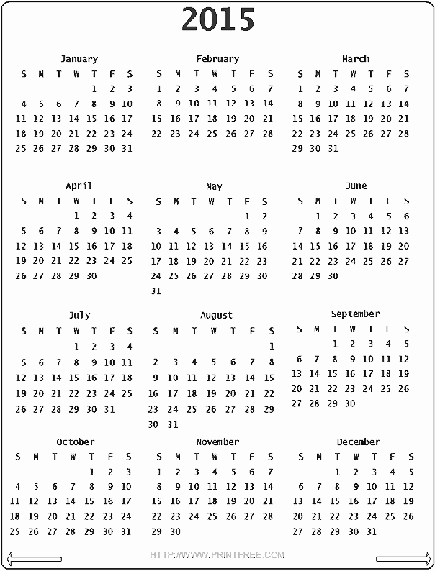

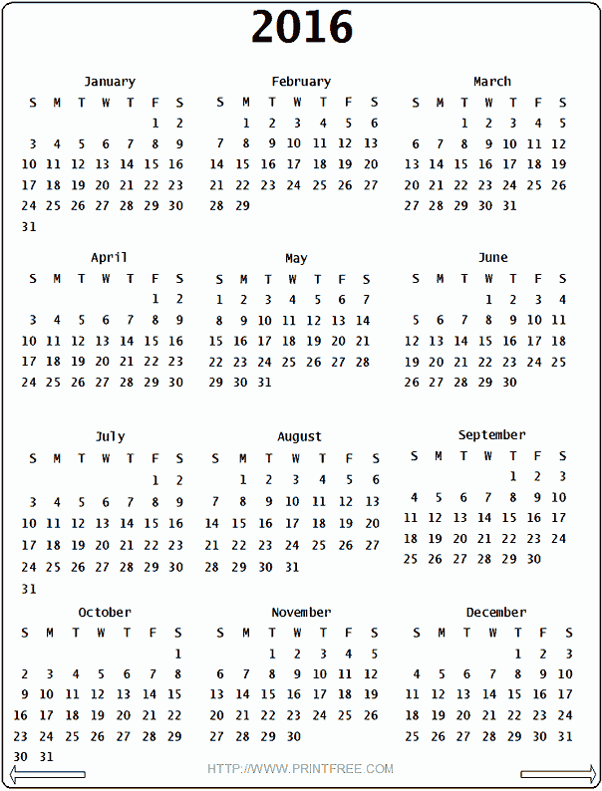

**NOTES**

**NOTES**